

PMRI Student Guide

2024

1/29/2024

DISCLAIMER: This booklet is produced by graduate students that are or have been part of the Purdue Military Research Institute’s (PMRI) Graduate Program. The information presented herein is not endorsed by Purdue University nor PMRI. This is a compilation of PMRI student input and believed to be helpful for those who are new to the Lafayette/West Lafayette areas. Please administer due diligence before pursuing any recommendations contained within.

Contents

# PMRI Welcome Letter Error! Bookmark not defined.

Points of Contact at Purdue 4

Air Force In-Processing (See Checklist in Appendix) 0

Air Force Related Topics 3

Space Force In-Processing 5

Space Force Related Information 6

Navy In-Processing 7

Navy Related Topics 8

Army in-Processing 10

Army Related Topics 11

General Military Information 12

Medical and Dental Information 14

Housing and Schools 16

Parks and Recreation 20

Gyms 24

Useful Academic Information 25

Useful Information for the Greater-Lafayette area 26

Spouses and Families 30

Appendix A: Air Force Civilian Institute In-Processing Checklist (CAO Oct 2020) Error! Bookmark not

defined.

Appendix B: Military Ranks 36

**Purdue Military Research Institute Welcome Letter**

Welcome Sir/Ma’am,

We are happy to have you join us here at Purdue University for your graduate education and look forward to your contributions to our community! Home of the Boilermakers, Purdue University is an internationally recognized university that enjoys high rankings for the quality of our education and research. Purdue is also notable for its welcoming atmosphere, which is particularly evident for our military members and their families. While you serve here, the Purdue Military Research Institute will form the backbone of your support network, and you can count on our faculty and staff to provide support and guidance throughout your time here. Our group of more than sixty officers that make up the PMRI cohort bring with them a varied mix of backgrounds and areas of expertise, as we host students from the Army, Navy, Marines, Air Force, Coast Guard and Space Force.

During your time here, you may be asked to address some of the most difficult technical challenges facing our country and the national defense community. We don’t think you’d expect less…and we know you’re up to the task based on your past track record. You’ll now study with some of the world’s foremost researchers who are surrounded by other gifted students. So, eat a big breakfast, tie your shoes on tight, and bring your “A” game…Purdue academics and research will require all of that for you to succeed. But succeed you will…we enjoy a 98% success rate for on-time graduations…and have every confidence that your name will be included on that elite list.

While you are at Purdue, we also encourage you to make the most of your time outside of the lab or classroom. Boilermaker sporting events, intramural sports, and affinity clubs are varied and abundant places to connect with other campus students. In addition to our campus, the Greater Lafayette/Tippecanoe County area hosts numerous public parks, rich historical sites, and a vibrant community.

As you begin your studies, please feel comfortable reaching out to your fellow PMRI students, our PMRI faculty and staff, your academic advisors, and your civilian colleagues—they all want to see you succeed!

In this guide, you will find the institutional wisdom of those that have come before you. It is full of general advice, recommendations on things to do in the local area, and places you can look to for help when you get stuck. It is meant to help you ask the right questions as you develop a roadmap for your graduate education. Suggestions are welcome for future editions, especially if it makes the transition to Purdue a little easier for the next officer.

We wish you the best of luck as you begin your journey here at Purdue. Boiler Up!

# Points of Contact at Purdue

Purdue Military Research Institute:

* Website: <https://www.enginnering.purdue.edu/PMRI/>
* POCS:

Dave Hankins, Col, USAF Ret., 765-427-8621 Eric Dietz, PhD, LTC, USA Ret., 765-494-8130

* PMRI Welcome Picnic (a lunch to be held the week before Fall semester starts, August)
* PMRI December Gathering
* PMRI Seminar Course (Mandatory in the Fall, Suggested in the Spring) Air Force AFIT LNO
* Major Derek Lageman (CAO: Feb 24) Space Force Senior Student
* Lt Ashwin Sivakumar (CAO: Feb 24) Navy Senior Student
* LCDR Christine Cairoli (CAO: Aug 22) Army Senior Student
* MAJ (S) Nick Harrell (CAO: Sep 21) Marine Corps Senior Student
* Vacant currently Purdue AF ROTC
* Website: <https://polytechnic.purdue.edu/afrotc>
* Phone: 765-494-2042 (Front Desk)
* Email: [afrotcdet220@purdue.edu](mailto:afrotcdet220@purdue.edu)
* PAS: Col Joseph McKenna Purdue Army ROTC
* Website: <https://polytechnic.purdue.edu/armyrotc>
* Phone: 765-494-2099
* PMS: LTC Kevin White Purdue Navy ROTC
* Website: <https://polytechnic.purdue.edu/nrotc>
* Phone: 765-494-2055
* PNS: CAPT Chris Nelson
* Email: [nrotcbo@purdue.edu](mailto:nrotcbo@purdue.edu)
* Marine POC: CAPT Joshua Calderon, Marine Officer Instructor
  + Email: [calder48@purdue.edu](mailto:calder48@purdue.edu)

Purdue Veterans’ Success Center

* <https://www.purdue.edu/veterans/>
* 765-494-7638
* They are your POC for applying for in-state residency for purposes of in-state tuition. See instructions in your PMRI Fellowship offer letter or if coming w/funding from your Service, you should still apply and save significant monies over paying non-resident fees. It’s a simple

application process and you’ll be approved….but you must apply!

# Air Force In-Processing (See Checklist on AFIT CIP website)

MPF

* Checklist: <https://cip.afit.edu/CIPPORTAL/>
* Org Boxes
  + Force Management: [88mss.dpmo@us.af.mil](mailto:88mss.dpmo@us.af.mil)
  + Customer Service: [88mss.dpmc@us.af.mil](mailto:88mss.dpmc@us.af.mil)
* 88 FSS/FSDE Formal Training [<88FSS.FSDE.FormalSchools@us.af.mil](mailto:%3c88FSS.FSDE.FormalSchools@us.af.mil)>
  + This might be useful for UPT, IFT, or other PCS to Training scenarios
  + (937) 904-4888 AFIT PAS Code
* WE0JFY7. (Make sure this is correct otherwise you will have issues utilizing other systems) AFIT CSS POCs
* [CSS@afit.edu](mailto:lacey.erbe@afit.edu)
* **As a last resort** Reach out to Gary Morris to in-process with AFIT. The local detachment does not have full access to your personnel file to make all the necessary updates you need.
  + [gary.morris.2@us.af.mil](mailto:gary.morris.2@us.af.mil) / gary.morris@afit.edu

Duty Title

* MS Student: AFIT CI MS Student
* PhD Student: AFIT CI PhD Student AFIT DTS
* TSgt Ashley Krueger, [ashley.krueger.3@us.af.mil](mailto:ashley.krueger.3@us.af.mil) AFIT Fitness Manager
* MSgt Alexander Moyo, [Alexander.Moyo@us.af.mil](mailto:Alexander.Moyo@us.af.mil) AFIT Security Office
* [afit.ci.security@us.af.mil](mailto:afit.ci.security@us.af.mil)
* Greg Dixon, [gregory.dixon.ctr@afit.edu,](mailto:gregory.dixon.ctr@afit.edu) 937-255-6565 x3118
* MSgt Lacey Erbe (AFIT/CI Security Assistant), [lacey.erbe@us.af.mil](mailto:lacey.erbe@us.af.mil) Finance:
* Email [payhelp@us.af.mil](mailto:payhelp@us.af.mil) with your orders stating you want to in-process.
* Submit your travel claim through: Comptroller Service Portal
  + <https://usaf.dps.mil/teams/SAFFMCSP/portal/SitePages/Home.aspx>
  + From Finance: In order to complete your PCS claim, we will need:
    - PCS orders (front and back copy)
    - Lodging receipts if you have recently completed a stay in temporary lodging or stayed in temporary lodging before PCSing (Lodging prior to departure or after arrival...authorized ~10 days reimbursement total)
      * This is different than the hotels you stayed in while in transit
      * A non-availability statement if applicable
    - Port lodging receipts
      * if you are coming from an OCONUS location
  + Most document forms will be provided for you.
  + If your email contains PII, or other sensitive information, please utilize SAFE APPS for secured file transfer to transmit these documents:
    - <https://safe.apps.mil/>
    - CAC required.
* Madison Kane, SrA, USAF, Financial Operations Technician, 88 CPTS/FMF, Civilian Pay/Military PCS Team Lead, Wright Patterson AFB, OH, Comm: (937)522-2079

WPAFB TMO:

* From WPAFB TMO:
  + Please submit all information and documentation listed on the attached PPM Documentation Collection Sheet to:
    - [WPAFBTMO@US.AF.MIL](mailto:WPAFBTMO@US.AF.MIL)
    - You will need to print off the DD Form 2278 and DD Form 1351-2 from your account in the DPS system at [www.move.mil](http://www.move.mil/)
    - Anna (Suzie) Puckett, Contractor, Personal Property Lead, WPAFB
      * Comm (937) 257-2153 DSN 787-2153
      * Fax (937) 257-3477 DSN 787-3477

DEERS (Local)

* Lafayette Armory (id cards, DEERs updates, etc.)
  + 5218 Haggerty Lane, Lafayette, IN 47905, (317) 247-3300 (near YMCA)
* Grissom Air Reserve Base (DEERS, id cards)
  + BLDG 598, Room 138, (765) 688-3909

Awards and Decorations

* Ms. Taiesha Williams (WPAFB) can update your awards and decorations
  + [taiesha.williams.1.ctr@us.af.mil](mailto:taiesha.williams.1.ctr@us.af.mil)

LeaveWeb

* <https://leave.af.mil/login>
* Senior Student should be primary, PM should be alternate
* AFIT/CI requires additional COVID paperwork/approval, so plan leave in advance to ensure proper processing time with your program manager, checklist on AFIT CIP Website.
* Under 26 requires additional safety briefing and form.
* AFI 36-3003 governs Leave. vRED
* Update through vMPF, which can be accessed through AF Portal.

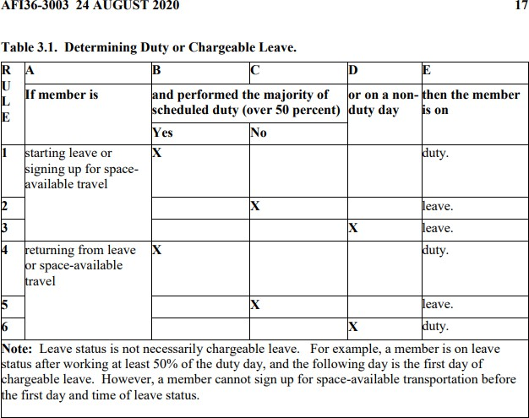

AFIT CIP Portal

* <https://cip.afit.edu/cip/>
  + Course plan submitted before first term; grades submitted after each term
* Form 9 should be confirmed and submitted for assignments

# Air Force Related Topics

Air Force Connectivity

* Webmail: <https://webmail.apps.mil/mail/inbox>
* VPN to AFNET: VMware Horizon Client (how-to provided on AF Portal)
* Notice: officers coming straight from a commissioning source may not have an @us.af.mil (or Space Force email). This may limit the younger officers’ ability to resolve various personnel issues that arise and may require accessing various Air Force sources (such as GAL or webmail).
  + Accessing vMPF may require an email. You can try spoofing it by giving it a placeholder email for the moment and then fixing it once the account was created

Motorcycle Riding

* Motorcycle Safety training course is covered by AFIT/Safety Office.
  + The course is offered in Frankfort, In (about 30-45 minutes away).
  + Military riders can get resident rates (~150$).
    - Cost is fully refundable.
* Timothy Thomas ([timothy.thomas@afit.edu](mailto:timothy.thomas@afit.edu)) manages the MUSST Accounts.
* Several Students have motorcycles and can be mentors in accordance with motorcycle safety program guidance.

Air Force Mentorship

* Reach out to various O-6 types for mentorship. These folks can provide great insight. Below are a few recommendations for those looking for mentors especially in the 6X community
  + Col Michelle Ewy (Deputy Director AFRL-Stuff/AFOSR): PhD in chemistry, huge supporter of STEM AAD efforts, former Aide to AF Chief Scientist, Retires in 2022
  + Col Jason Bartolomei (AFNWC GBSD SML/Director, he’s the guy in-charge, but the naming convention changes based on the season), PhD from MIT, really receptive and engaging

Promotion

* A Promotion Recommendation Form (PRF) should be completed by previous unit prior to your school assignment.
  + If you are due for a promotion, it is on you to check and make sure your paperwork is where it needs to be.

AFIT Patches for OCPs

* <https://www.reaperpatches.com/products/af-institute-of-technology?variant=35305575743655>
* There is a small number of patches locally within the AF Corps of PMRI...ask the Sr Student Fitness Testing
* Det 220 (Purdue) administers the tests, coordinate through Senior Student
* Schedule early
  + Testing is historically offered prior to Fall semester following arrival of new students
* Make sure PAS Code is updated or there may be an issue linking your myFSS/myFitness account with your score.

# It is your responsibility for staying current / green on all personnel readiness issues

Periodic Health Assessment (See Medical Section)

* Should be accomplished annually Signature Blocks
* There is no standardize format nor a requirement to have a signature block, but if you choose to create one, please comply with the proper abbreviations and common format.
* Some examples are provided:

**PMRI Recommended:**

First M. Last, Rank, Service

Purdue Military Research Institute Fellow, (MS/PhD) Student/Candidate https://engineering.purdue.edu/PMRI

Other Examples:

Rank First Last

PhD Student, AFIT/CIG (Purdue University) [name@purdue.edu](mailto:rmickels@purdue.edu)

Cell: XXX-XXX-XXXX

First M. Last, 2d Lt, USAF

AFIT MS Student, Purdue University

(Note: Instead of AFIT MS Student, you could also put your degree program like AAE MS Student or you could list AFIT/CIG. It is not unreasonable to change this line based on who you are communicating with)

FIRST M. LAST, 2d Lt, USAF

DAWN-ED Graduate Student PMRI, Purdue University XXX.XXX.XXXX

First M. Last, Rank, Service

Purdue Military Research Institute Fellow, Degree (if you work in one) Name of Lab/Center

School (eg School of Aeronautics and Astronautics)

Purdue University email[@purdue.edu](mailto:nottinge@purdue.edu)

https://engineering.purdue.edu/PMRI

First M. Last

Graduate Candidate, Purdue University

First M. Last

AAE MS Candidate, Purdue University

# Space Force In-Processing

See Air Force In-Processing

# Space Force Related Information

Space Force Portal: https://[www.my.spaceforce.mil/login](http://www.my.spaceforce.mil/login)

# Navy In-Processing

Email the Purdue Navy ROTC admin Team to start Check-in: [nrotcadmin@purdue.edu](mailto:nrotcadmin@purdue.edu)

# Navy Related Topics

The Navy ROTC Commander is responsible for all Navy students while at Purdue University. The Commander is responsible for FITNESS reports and approves all liberty and leave chits. All Navy students are encouraged to contact the Navy ROTC Commander or XO upon arrival.

Periodic Health Assessment (PHA)

* One option is to register through Great Lakes, Captain James A. Lovell Federal Health Care Center, and then do a virtual PHA annually
  + Call to Register stating registration to complete annual active duty PHA: 224-610-3747
  + Follow instructions in the Periodic Health Assessments section to complete online portion and schedule PHA appointment: https://[www.va.gov/lovell-federal-health-care-](http://www.va.gov/lovell-federal-health-care-) tricare/programs/fisher-clinic-operational-medicine/

# Army in-Processing

In-process with the US Army Student Detachment (USASD) at Fort Jackson as outlined in your orders. Links to forms and processes can be found here: <https://usacimt.tradoc.army.mil/ltb/usasd/index.html>

USASD falls under Training and Doctrine Command (TRADOC); if you need to wear ACU/OCP for an event, patch available here: <https://www.shopmyexchange.com/army-unit-patch-tradoc/1272804>

USASD can often be, unhelpful. Reach out to one of the current student Officers at Purdue if you run into issues, they can point you in the right direction or advise on how to approach the situation.

# Army Related Topics

Placeholder

# General Military Information

Arrival Date:

* If you already have housing secured/arranged, arriving two weeks prior to start of classes is usually sufficient to get settled. Typically, classes begin the 3rd week of August.
  + You will want all this time to get your affairs in order prior to starting your classes, so take this into account when you are requesting an arrival date.
    - It is a sprint until Christmas break, then you will get ~ two weeks off, then it is another sprint to summer break, then you will get ~ two weeks off...rinse and repeat

Applying for In-State Tuition/Residency

* For those on PMRI Fellowships, your offer letter asks you to apply for in-state residency once you have orders.
  + Please note that this is for tuition purposes only…does not affect your legal state of

residency.

* + It’s a very easy process…just follow the directions on your offer letter.
* If not on a Fellowship, go to the Purdue Registrar website and look for “Residence Classification

Information for Military Personnel” and follow the directions.

* There is a deadline for filing and failing to do this, could cause you to be responsible for the difference in costs of in-state and out of state tuition.

# Waivers for failing to submit the application on time are extremely rare!

BAH Rate (<https://www.defensetravel.dod.mil/site/bahCalc.cfm>)

* $ 1,278/month, O-1, no-dependents (2024)
* $ 1,992/month, O-3, with-dependents (2024) Car/Vehicle Registration
* Cars can be registered in Indiana as a non-resident.
* If you are a non-resident, you are exempt from various Indiana vehicle/use/wheel taxes.
  + https://[www.in.gov/bmv/resources/military-families/](http://www.in.gov/bmv/resources/military-families/)
  + Tax should be around $50 to register your car.
  + *State Form 46402* is required, but it can be signed by Senior Student, who verifies you are in Indiana on military orders and are not a resident.

Purdue Parking

* Purdue has various parking passes, and as a grad student living more than 1.5 miles from campus, you may purchase a C pass without any restriction.
* PMRI has secured the privilege of being able to purchase A and B passes, just like faculty and staff.
  + ‘A’ passes cost $250 per year (August to August)
  + NOTE>>>>you can only have one kind of pass at a time…and once purchased, it’s yours for whatever time commitment you agreed to.
* Prior to the Fall and Spring semesters, PMRI leadership will reach out and ask if you’d like to purchase an upgraded parking pass. They will then send a list of those students that want the upgrades to Parking Facilities for review/approval. Approval typically happens only a few days prior to classes starting.
  + While we’ve tried to accelerate that approval, we have not been successful. That said, it

truly is a privilege that we’re being given to have an A or B pass.

* + Please don’t “brag” about this to your fellow grad students who are having to purchase

C passes. **This privilege could easily be lost.**

* Purdue is notorious for giving out parking tickets (~$70). They have a whole fleet of parking cops checking every spot on campus multiple times a day; a parking permit is very worthwhile, especially with PMRI helping us purchases employee-level permits (A & B).
* For those who need to make frequent trips to classes on campus, the A permit will allow you to park in prime locations like covered parking garages close to academic buildings (see map linked below).
* The B and C permits are the same price, but B has more locations.
* Free street parking can be found on Waldron Street, but these spots are usually taken by the fraternities and sororities. More free spots are found in the streets off campus east of the sports complex and Northwestern Ave. Sylvia St has free two-hour parking on the street and is very close to most engineering buildings.
  + NOTE>>>>Moving your car to another free parking location on the same block does NOT

restart the parking clock. If you’re going to move it, move it to a different block.

* https://[www.purdue.edu/campus-map/parking.html](http://www.purdue.edu/campus-map/parking.html)

MyPay

* [https://mypay.dfas.mil/#/](https://mypay.dfas.mil/%23/)
  + Can check paystubs and get tax documents (travel/PCS W-2s as well as annual W-2)
  + Can set up allocations and contributions to TSP here.
  + Can change tax withholdings (W-4 status)

TSP

* <https://www.tsp.gov/>
* 401k-like retirement account, which needs to be logged into and setup.
  + Recommend investing your money in ROTH TSP
    - Contributions / Allotments can be setup in MyPay.
  + How your money is invested needs to be established on the TSP.gov website
  + Information about funds is here:
    - <https://www.tsp.gov/funds-individual/>
    - <https://www.tsp.gov/funds-lifecycle/>
      * Most people would do fine investing in a lifecycle fund with a target decade of your retirement
* May require you to request password and log-in information via mail

Local Military Bases

* Lafayette Armory (National Guard, can replace military and spouse ID cards)
* Fort Benjamin Harrison (Indianapolis, home of DFAS) 1 hour drive
* Grissom Air Reserve Base, Kokomo (45 minutes to 1 hour)
* Crane Naval Base / NSA Crane
* Wright-Patterson, OH (serving MPF)
  + ~ three hour drive
* Fort Knox, KY
* Scott AFB, IL
  + Four hour drive
* Great Lakes Naval Base (2.5 hour drive)

# Medical and Dental Information

Medical

* Should have an annual Periodic Health Assessment (PHA), **which is a READINESS item**
* 88th BOMC (Base Occupational Medical Clinic)
  + For updating your annual PHA and other health/medical record updates such as vaccines
  + Phone number: 937-255-8226
  + Points of Contact:
    - Mike Girard: [michael.k.girard.civ@mail.mil](mailto:michael.k.girard.civ@mail.mil)
    - James Boshonek: [james.p.boshonek.civ@mail.mil](mailto:james.p.boshonek.civ@mail.mil)
  + Org Box: USAF Wright-Patterson AFB 88 MDG Mailbox BOMC [usaf.wright-patt.88-](mailto:usaf.wright-patt.88-mdg.mbx.bomc@mail.mil) [mdg.mbx.bomc@mail.mil](mailto:usaf.wright-patt.88-mdg.mbx.bomc@mail.mil)

Immunization Clinic

* May not answer phone – 937-257-3822 Local Medical Providers
* The providers need to be certified with Tricare, so just because they are in the same office does not mean they will necessarily be covered.
* Franciscan (TRICARE in-network provider)
  + There is a sports (and family) medicine clinic at the YMCA building (Lafayette)
  + There is a clinic off of Sagamore Pkwy, near Salisbury in West Lafayette
    - Lisa Turner is a nurse practitioner and is, at least, familiar with paperwork and processes of PHAs.
* Referrals can be easily made through the Primary Care Physician (PCP / PCM [manager])
  + Out of network if appointments cannot be made within 60 days or the drive is greater than 1hr drive
  + A particular issue for urology (maybe you are thinking of a vasectomy by someone that does it for a living, rather than a military doc who does not)
    - Franciscan **does not** have an in-network provider that can meet these requirements
  + Humana Miliary (Tricare East) Website: <https://www.humanamilitary.com/>
    - Able to register and see referral approval information here
    - If you have a referral to a provider you do not prefer, you can look up other providers and call Humana to change the provider

Local Pharmacies (In-network)

* Walgreens
* Meijer
  + Flu shots can be done here Flight Physicals
* Wright-Patterson Air Force Base Dental

# Form DD 2813 required each visit

* + [**https://www.hqmc.marines.mil/Portals/133/Dental_dd2813.pdf**](https://www.hqmc.marines.mil/Portals/133/Dental_dd2813.pdf)
  + Email to Wright Patterson Dental Clinic (Aug 21)
    - King, Ana A TSgt USAF 59 MDW (USA) [ana.a.king2.mil@mail.mil](mailto:ana.a.king2.mil@mail.mil)
    - Dummitt, Michael T SSgt USAF (US) [michael.t.dummitt.mil@mail.mil](mailto:michael.t.dummitt.mil@mail.mil) (DSN: #937-257-8761)
* Knop Family Dentistry (Lafayette)
  + Takes and is familiar with Tricare (United Concordia)
  + Laid back, not super aggressive dentist
  + Great communication (email and SMS reminders for appointments)—helpful for a busy schedule.
* Deerfoot Trails Density
  + Same as Knop and located on Veterans Memorial Highway
* Pediatric Dentistry West: Dr. John and Dr. Zach Bozic (West Lafayette)
  + Takes Tricare (United Concordia)
  + Great with kids
* Dental Care of Indiana (West Lafayette)

# Housing and Schools

General thoughts on housing:

Housing options are, generally speaking, limited even compared to the current state of the housing market. Everyone is on basically the same moving cycle: depart in Spring/Summer, arrive in Summer/Fall. Housing in West Lafayette is, generally speaking, strong due to lack of building and limited supply for 3+ room houses. Basements are hot commodities. Contracts are hard to get accepted with VA loans due to an influx of investors and cash offers being made by (usually international) competition.

* Typically avoid Lafayette inside (west) of Route 52 and north of Teal
* Suggested to avoid area near the Tate and Lyle plants…it’s stinky
* Most officers with families choose to live in West Lafayette
* Klondike area (Lindberg Village, Blackthorn neighborhood, etc. “West of 231”) (West Lafayette)
  + Seems to be very family friendly, lots of families with children
  + Western edge of West Lafayette
  + Very commutable to the University, but much longer drive to things in Lafayette (mall,

YMCA, Churches, Sam’s Club, Home Depot, Lowes, etc.)

* + Strong schools (but not considered as strong as West Lafayette Schools)
* Residential West Lafayette (north of University, circa Salisbury Rd, River Rd, Lindberg Ave, etc.,

“East of 231, South of 52”)

* + Older, pricier homes
  + Convenient location to grocery stores, eateries, campus, etc.
* West Lafayette (Near Harrison HS, circa Kalberer Rd, “North of 52”)
  + There are some newer homes and neighborhoods
  + Seem to be a little more expensive
  + Anecdotally, this is where the professors live
* Battle Ground (Near Prophetstown State Park, West Lafayette address)
  + Farther away from most things with older, affordable homes
  + Strong schools
  + Some historical museums
  + The local legend states that the *War of 1812* began here
* South Lafayette circa Veterans Memorial Parkway
  + Seems to be family friendly
  + Further from university but closer to mall, etc.
  + Seems to be a growing area with newer construction
* Zillow Data
  + [Houses for Sale](https://www.zillow.com/homes/for_sale/?searchQueryState=%7B%22pagination%22%3A%7B%7D%2C%22usersSearchTerm%22%3A%22West%20Lafayette%2C%20IN%22%2C%22mapBounds%22%3A%7B%22west%22%3A-87.24920584082031%2C%22east%22%3A-86.66555715917968%2C%22south%22%3A40.30494807140278%2C%22north%22%3A40.64654284636741%7D%2C%22isMapVisible%22%3Atrue%2C%22filterState%22%3A%7B%22ah%22%3A%7B%22value%22%3Atrue%7D%7D%2C%22isListVisible%22%3Atrue%2C%22mapZoom%22%3A11%7D)
  + [Houses for Rent](https://www.zillow.com/homes/for_rent/?searchQueryState=%7B%22pagination%22%3A%7B%7D%2C%22usersSearchTerm%22%3A%22West%20Lafayette%2C%20IN%22%2C%22mapBounds%22%3A%7B%22west%22%3A-87.24920584082031%2C%22east%22%3A-86.66555715917968%2C%22south%22%3A40.30494807140278%2C%22north%22%3A40.64654284636741%7D%2C%22isMapVisible%22%3Atrue%2C%22filterState%22%3A%7B%22ah%22%3A%7B%22value%22%3Atrue%7D%2C%22fr%22%3A%7B%22value%22%3Atrue%7D%2C%22fsba%22%3A%7B%22value%22%3Afalse%7D%2C%22fsbo%22%3A%7B%22value%22%3Afalse%7D%2C%22nc%22%3A%7B%22value%22%3Afalse%7D%2C%22cmsn%22%3A%7B%22value%22%3Afalse%7D%2C%22auc%22%3A%7B%22value%22%3Afalse%7D%2C%22fore%22%3A%7B%22value%22%3Afalse%7D%7D%2C%22isListVisible%22%3Atrue%2C%22mapZoom%22%3A11%7D)
  + [Houses Sold Recently](https://www.zillow.com/homes/recently_sold/?searchQueryState=%7B%22pagination%22%3A%7B%7D%2C%22usersSearchTerm%22%3A%22West%20Lafayette%2C%20IN%22%2C%22mapBounds%22%3A%7B%22west%22%3A-87.24920584082031%2C%22east%22%3A-86.66555715917968%2C%22south%22%3A40.30494807140278%2C%22north%22%3A40.64654284636741%7D%2C%22isMapVisible%22%3Atrue%2C%22filterState%22%3A%7B%22ah%22%3A%7B%22value%22%3Atrue%7D%2C%22fsba%22%3A%7B%22value%22%3Afalse%7D%2C%22fsbo%22%3A%7B%22value%22%3Afalse%7D%2C%22nc%22%3A%7B%22value%22%3Afalse%7D%2C%22cmsn%22%3A%7B%22value%22%3Afalse%7D%2C%22auc%22%3A%7B%22value%22%3Afalse%7D%2C%22fore%22%3A%7B%22value%22%3Afalse%7D%2C%22rs%22%3A%7B%22value%22%3Atrue%7D%7D%2C%22isListVisible%22%3Atrue%2C%22mapZoom%22%3A11%7D)
* Apartments
  + West Lafayette (Close to campus) – pay between $750-$1000/month per person depending on roommates – walk to campus buildings, restaurants/bars
    - 120 Fowler Flats – New building, maybe not the best management
    - Rise and The Hub – Luxury new buildings (more toward $1000+/month)
    - Generally, AVOID Granite Management
    - The Fairway Apartments – DO NOT LIVE HERE. Management is horrible
    - Burgett Rentals (John Burgett – 765-427-1684) - Several homes in good location. John is a reasonable landlord
  + West Lafayette (Away from campus) – pay between $400-$600/month per person depending on roommates – generally quieter, and larger scale (“mass production” undergraduate living). Look close to Celery Bog for walking/biking trail. Many places have busses to take you to campus.
    - The Cottages
    - Village West
    - University Place
    - The Lodge on the Trail
      * Really nice complex with vast amenities
      * Next to Walmart
    - Lark & Alight
    - Redpoint
  + Downtown Lafayette – pay between $450-$600/ month per person depending on roommates – walk to downtown restaurants/bars (generally better food options)
    - South Street Lofts – Good looking loft style, decent management
    - Historic Lahr Apartments – Nice older building in heart of downtown
* Handymen / Contractors
  + Remodeling Work
    - Ben Hoskins
      * [getbenhere@gmail.com](mailto:getbenhere@gmail.com)
    - Tolentino Tile & flooring
      * 765-714-7688
  + Carpet Cleaners
    - Chem-Dry of Lafayette
      * <https://www.carpetcleanerlafayetteindiana.com/>
      * ~1000sqft = ~300$
  + HVAC Service
    - F&S Williams, Inc
      * <https://fswilliams.com/>
      * 150$/year service contracts for Heating and AC
      * Very thorough and honest
    - Brand HVAC
      * <https://www.brandhvac.com/>
      * Consistently tried to upsell and over diagnose problems

Schools

* Klondike Elementary / Klondike Middle School (West of 231, off of 52)
* West Lafayette School District
* Lafayette Catholic School System Preschools

Information and Fees (Current as of Jan 2022)

* [Christ United Methodist Church Early Learning,](https://christumchurch.org/ministries/early-learning/) 3610 S 18th St Lafayette, IN
  + Moms Time Out: 12 months- 3 years (Must be walking, doesn’t have to be potty trained)
    - M or W or F: 9:15-11:45 @ $60.00 per month
  + Young Threes: Must be 3 years old by 12/31/22 (Potty trained required)
    - T and Th: 9:15-11:55 @ $135.00 per month
  + 3/4 Class: Two different offerings (3 year old by 8/1/22 and Potty trained)
    - MWF or T/Th: 9:15-11:55 @ $135 per month (2-day option) or $165 per month (3-day option)
  + Preschool Class:
    - MTWTh: 9:15-12 @ $190.00 per month
* [Saint Francis Early Learning,](https://www.lcss.org/apps/pages/index.jsp?uREC_ID=2074779&type=d&pREC_ID=2130241) 1223 N 16th St Lafayette, IN (Catholic School System)

*Discounts available based on income level and/or church affiliation

* + Preschool 3’s: 3 by August 1
    - M-F 8 a.m.- 3 p.m. @ $660.00 per month
    - M-F 7 a.m.- 5:30 p.m. @ $740.00 per month
    - AM ½ day M-F 8- 11 a.m. @ $425.00 per month
    - PM ½ day M-F 12-3 p.m. @ $425.00 per month
    - AM ½ day T and Th 8-11 a.m. @ $178.00 per month
  + Preschool 4/5’s: 4 by August 1
    - M-F 8 a.m.- 3 p.m. @ $660.00 per month
    - M-F 7 a.m.- 5:30 p.m. @ $740.00 per month
    - AM ½ day M-F 8- 11 a.m. @ $425.00 per month
    - PM ½ day M-F 12-3 p.m. @ $425.00 per month
    - AM ½ day MWF 8-11 a.m. @ $266.00 per month
    - PM ½ day MWF 12-3 p.m. @ $266.00 per month
    - School day MWF 8 a.m.-3 p.m. @ $410.00 per month
    - All day MWF 7 a.m.-5:30 p.m. @ $460.00 per month
* [Saint James Lutheran School,](http://www.stjameslaf.org/school/Preschool.cfm) 615 N 8th St Lafayette, IN

*Email [julieg@stjameslaf.org](mailto:julieg@stjameslaf.org) for tuition information

* + Childcare: Nursery 6 weeks – 15 months
  + Toddler Room: 15 months- 24 months
  + Half day Preschool: 7:30-12:30
  + Full day Preschool: 7:30-5:25
  + Preschool 2’s: 2 by Aug 1
  + Preschool 3’s: 3 by Aug 1 and potty-trained
  + Pre-kindergarten: 4 by Aug 1
* [Faith West/East Preschool,](https://www.faithlafayette.org/childcare/preschool) 1920 Northwestern Ave Building 3 West Lafayette, IN

*Same price for both locations. Contact for tour to find out more information.

* + Early 3’s @ $38.89 per week
  + K3 @ $55.00 per week
  + K4 @ $72.22 per week
  + Preschool Full Time @ $161 per week
  + K5-full day @ $538.00 per month
  + K5-half day @ $395.00 per month
* Village Nursery, 1700 IN-26, West Lafayette, IN
  + Preschool 2’s: 2 by Aug 1
    - T/Th, 9:20-11:50am @ $95.00 for 2 classes per week
    - T/Th, 12:30-3pm @ $95.00 for 2 classes per week
    - MWF, 9:20-11:50am @ $130 for 3 classes per week
  + Preschool 3: 3 by Aug 1
    - T/Th, 9:20-11:50am @ $95.00 for 2 classes per week
    - MWF, 9:20-11:50am @ $130 for 3 classes per week
    - T/W/Th, 12:30-3pm (for older 3/4/5 year-olds) @ $130 for 3 classes per week
  + Pre-Kindergarten: Must be 4 by Aug 1
    - MWF, 9:20-11:50am @ $130.00 for 3 classes per week
    - T/W/TH, 12:30-3pm (for older 3/4/5 year-olds) @ $130.00 for 3 classes per week
    - M-F, 9:20-11:50am @ $210.00 for 5 classes per week
  + Preschool Spanish: Must be 4 by Aug 1
    - T/Th, 9:20-11:50am @ $100 per month for 2 classes per week
  + P.I.T.: Class for toddlers 12-24 months
    - T, W, Th, or F 9:30-11 @ $125/semester
  + Stay and Play: 12 months and walking
    - 8:45-12pm @ $25.00 flat rate
* Little Bronchos (Offered through Lafayette Public Schools--Inside Linnwood, early childhood center)
  + AM Program
    - M-F, 9-11:30am @ $50.00 per week
  + PM Program
    - M-F, 12:15-2:45pm @ $50 per week

Day/Child Care

# [Christ United Methodist Church Early Learning,](https://christumchurch.org/ministries/early-learning/) 3610 S 18th St Lafayette, IN

* + All day care options

# Parks and Recreation

Playgrounds and Parks

* Indiana Dunes National Park
  + May be a fee for parking, but presenting a military ID may waive the fee YMMV
  + Recommend a different beach as this sits between several refineries in Gary, IN
* Turkey Run State Park
  + One of the nicest places to hike in Indiana (1hr south of West Lafayette)
  + Hiking, camping, kayaking, Horseback riding
* Celery Bog (West Lafayette)
  + 1620 Lindberg Rd West Lafayette, IN
  + Great running trails near off-campus apartments
  + 4.3 Miles paved trails
* Fair Oaks Farms
  + Off of I-65 Exit 220, 45 minutes north of West Lafayette
  + GREAT ice cream if you’re going to/from northern Indiana!
  + Has tours of their milking and pork operations. You likely haven’t seen anything like this…the kids will enjoy it…and expect that you will too!
  + They also have an up-scale restaurant on site…reservations may be required.
* Happy Hollow, 1301 Happy Hollow Rd West Lafayette, IN 47906
  + Site of PMRI Fall Gathering
  + The park contains 2 accessible playgrounds for ages 2-5 and 5-12, an open turf area and 5 picnic shelters. This park has parking lots. This also has a trail system with a winding creek kids can splash in.
* Columbian Park/Zoo, 1915 Scott St Lafayette, IN
  + Refurbished and developed in 2020/2021
  + The park has five different playgrounds ranging from ages 2-12, numerous picnic shelters, with on street parking. There is a parking lot near tropicanoe cove.
  + New Baseball Field called Loeb Field
    - Semi-professional baseball, Family friendly
  + Zoo
    - $2/person or family pass for ~ $30
  + Tropicanoe Cove (Water Park)
  + Train rides for children
  + Paddleboats
  + Carousel and Fishing in the future
* Munger Park, 3505 Greenbush St Lafayette, IN 47905
  + This park has one playground with three swings. The primary focus at this park is a stocked fishing pond, and a 0.9 mile loop trail that curves around the pond starting at the playground.
* McCaw Park, 3745 Union St Lafayette, IN 47905
  + The playground is situated on poured-in-place rubber surfacing, ensuring that all people can gain access to the facility.
* Tapawingo Park, Tapawingo Dr. West Lafayette, IN 47906
  + This is not a huge playground but has access to trails and is where you can ice skate outside in the winter.
* Armstrong, 821 Beck Lane Lafayette, IN 47909
  + This park is also where Castaway Bay is housed.
* Lommel, 300 Wilshire Avenue West Lafayette, IN 47906
  + Two playgrounds, balance beam, lots of swings. Can get muddy after a rain.
* Murdock, 2100 Cason Street Lafayette, IN 47904
  + Tot and multi-age playgrounds, a redesigned 18-hole disc golf course
  + Sled Run for the Winter with artificial snow
* University Farm Park, 490 LaGrange St. West Lafayette, IN 47906
  + This park has tons of pinecones if you ever are looking to find some for a project. This park has off street parking.
* Peck-Trachtman, 3300 Dubois St West Lafayette, IN 47906
  + There is a climbing boulder. This is an awesome park across the street from the West Lafayette Farmers Market.
* Prophetstown State Park, 5545 Swisher Rd West Lafayette, IN 47906
  + This state park has three playgrounds, one in the camping section, and two off the main road after the water park.
  + Entrance fees for in state license is $7.00 daily, out of state is $9.00 daily or $50.00 annual entrance permit to all State Parks in Indiana.
    - free during winter months
  + Camping, fishing, native interpretation sites, farm / homestead with live animals
  + Free Halloween event for kids
* Cumberland Park, 3065 N. Salisbury St West Lafayette, IN 47906
  + This park is where the West Lafayette Farmers market is held during the summer. It has a brand new playground next to the wellness center.
  + It also has garden plots that the community can rent out or they will allow nonprofits to use one of the four available based on first ask before season starts.

Festivals in Lafayette/West Lafayette

* Starry Night (West Lafayette, September)
* Sunflower Festival (Wea Orchard 3rd Weekend in July)
* Christmas Parade (Downtown Lafayette)
  + Early-December, family-friendly, entertaining, cold, over an hour long
  + Bring blankets and hot-chocolate

Gun Shops

* 4 Guns
* Applied Ballistics Gun Range (+rentals) Motorcycle
* Hunter’s Moon Harley Davidson
  + <https://huntersmoonhd.com/>
* Indian Motorcycle of Lafayette
  + <https://www.indianmotorcycleoflafayette.com/>

Ice Cream

* Original Frozen Custard
  + <https://www.originalfrozencustard.com/>
* Silver Dipper (Campus and West Lafayette)
  + <http://www.silverdipper.com/>
* Igloo Frozen Custard
  + <https://igloofrozencustard.com/>
* Budge’s
  + <https://www.budgesdrivein.com/>

# Food Local Restaurant Favorites

|  |  |  |  |
| --- | --- | --- | --- |
| **Mary Lou Donuts** 1830 S 4th St Lafayette, IN | **Mamma Ines- Mexican Bakery**  518 Sagamore Parkway N  Lafayette, IN | **Sweet Revolution Bakery**  109 N 5th St Lafayette, IN | **McCord’s Candies** Old fashioned soda locally made candy canes  536 Main St  Lafayette, IN |
| **Café Literato** | **Greyhouse Coffee** |  |  |
| 1920 Northwestern | Delicious crepes |
| Ave | 100 Northwestern Ave |
| West Lafayette, IN | West Lafayette, IN |
| **South Street Smoke** | **Triple XXX** | **DT Kirbys** | **Bru Burger** |
| **House** | Homemade root beer | Good burgers | 101 Main Street |
| 3305 South St | 2 N Salisbury St | 644 Main St | Suite 100 |
| Lafayette, IN | West Lafayette, IN | Lafayette, IN | Lafayette, IN |
| **Red Seven** | **East End Grill** | **The Bryant** | **Bistro 501** |
| 200 Main St | 1016 Main St | 1820 Sagamore | Special Occasions |
| Lafayette, IN | Lafayette, IN | Parkway W | 501 Main St |
|  |  | West Lafayette, IN | Lafayette, IN |
| **Thai Essence**  1534 Win Hentschel Blvd  West Lafayette, IN | **Maru Sushi**  Best Sushi  102 N Chauncey Ave D West Lafayette, IN | **Katana Sushi and Ramen**  Good sushi 1048C Sagamore Parkway W  West Lafayette, IN | **Sharmas Kitchen** Best Indian in town 1403 Sagamore Parkway North Lafayette, IN |
| **Bruno’s Pizza** 212 Brown Street West Lafayette, IN | **Fiesta Burrito** 2122 Veterans Memorial Parkway Lafayette, IN | **La Scala Italian**  312 Main Street  Lafayette, IN 47901 | **Another Broken Egg Café**  Only breakfast and lunch  516 Northwestern Ave  #1500  West Lafayette, IN |
| **Silver Dipper Ice Cream**  307 sagamore Pkwy W C  West Lafayette, IN | **Budges Drive-in**  Ice cream and drive in food  1102 N 14th St  Lafayette, IN | **Red Mango**  Frozen Yogurt  102 N. Chauncey Ave Ste B  West Lafayette, IN | **Town and Gown Bistro**  Great Brunch 119 N River Rd  West Lafayette, IN |
| 201 E State St  Lafayette, IN |  |  |  |

Veterinary Clinics

* VCA Paw Prints Animal Hospital, they have a care service that includes dental/shots/everything. Ask for Dr Brandon Cross.
* Low Cost Spay and Neuter (South Lafayette Area)
  + <https://lowcostspayneuterindiana.org/>
  + Bare bones services, but economical for shots, heartworm, flea/tick treatments
* Pets and Vets as Partners, 1220 Montgomery St, West Lafayette, In 47906, 765-463-7877
  + https://petsandvetsaspartners.com
* Blair Animal Clinic, 3662 N 250 W, West Lafayette, In 47906
  + [https://www.blairanimalclinic.com](https://www.blairanimalclinic.com/)

Groomers

* Pooch At Play Doggie Daycare, 2960 Lindberg Rd, West Lafayette, IN 47906
  + Groomer prioritizes dog comfort over having the best trim, by far the least expensive.

# Gyms

* YMCA offers free memberships to military members and their families
  + Just walk in with your CAC and sign some waivers.
  + Do not go through Military OneSource, AFIT, ROTC Units
    - YMCA is very familiar with military and takes care of you
  + Facility built in 2018 and is well maintained
  + Many free fitness classes
  + Swimming lessons $21/month for children
* Purdue gym - France A. Córdova Recreational Sports Center (“Corec”)
  + Membership included with Full-Time Student Status
  + Very Big, Very Nice, VERY busy during Fall and Spring Semesters
  + Free weights, cardio equipment, pool, basketball courts, racquetball courts, rock climbing
  + Currently need to make a reservation online (COVID rule – should end in Fall)
  + Paid classes (cycling/yoga) for ~ $50/semester unlimited plan
  + Paid lockers ~ $20/semester
* West Lafayette Wellness Center
  + <https://www.westlafayette.in.gov/department/index.php?structureid=277>
  + Built in 2021
  + ~ $70/month for family membership
    - May be able to get fee covered through Military OneSource, but not easy
* Cross Fit “Box” Gyms
  + Placeholder

# Useful Academic Information

* PowerPoint Templates for College of Engineering
  + https://engineering.purdue.edu/Communications/Branding/powerpoint-templates

# Useful Information for the Greater-Lafayette area

Map of Purdue

* [http://www.purdue.edu/campus_map/?_ga=2.190874669.620245064.1626707109-](http://www.purdue.edu/campus_map/?_ga=2.190874669.620245064.1626707109-62041572.1612894399) [62041572.1612894399](http://www.purdue.edu/campus_map/?_ga=2.190874669.620245064.1626707109-62041572.1612894399)

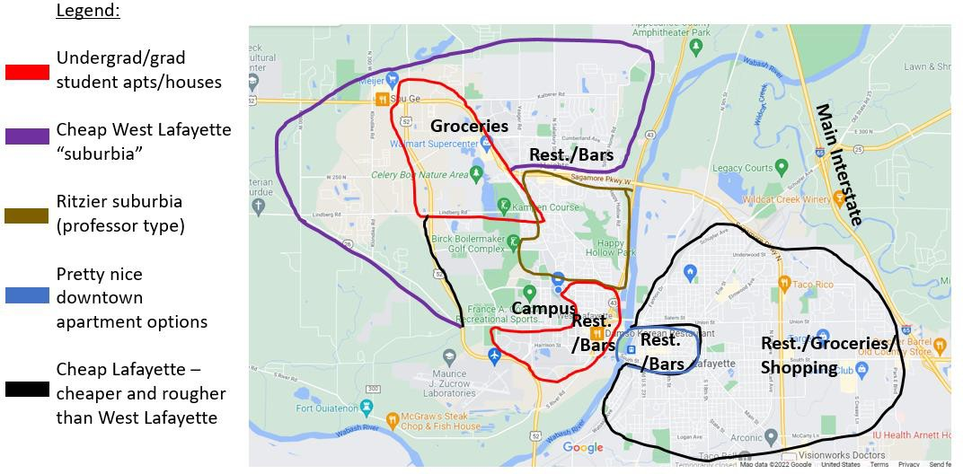

Internet Service Providers

* Comcast seems to have less outages than MetroNet for internet service, based purely on anecdotal evidence from monitoring neighborhood Facebook groups/Nextdoor.com.
  + MetroNet has faster speeds (fiberoptic) and a student discount. Extra Curriculars for Children
* Soccer
  + Greater Lafayette Regional Soccer Association
    - Inexpensive (50$/season) with Spring and Fall option
    - Always a need for volunteer coaches
    - <http://www.glrsa.org/clubsite/?p=5998>
  + Soccer Shots
    - Skills based soccer training/class
    - More expensive
    - Class consists of practice/game
* Malone’s Gymnastics
  + Semesterly schedule with varying price by age.
  + Summer camps are offered as well
  + <https://www.malonesgym.com/>
* CUMC Cheer and Basketball League
  + January through March
  + Kindergarten to 5th Grade
  + 60$ per child
  + Practice once per week, game on Saturday
  + Shirts, poms, and end of year gift included in price
* Sporties for Shorties
  + McAllister recreation ages 4-5 to expose them to different sports meeting 4 times
    - Basketball: March- April $25.00
    - T-ball: April - May $25.00
    - Soccer: June - July $25.00
    - Flag Football: August - September- $25.00
* Lafayette YMCA
  + Various Leagues offered throughout the year Military OneSource
* MilTax
  + Free HR Block Premium
    - Covers Real Estate, Stocks, Cryptocurrency, etc
    - Must access through link on Military One Source.
    - [https://www.militaryonesource.mil/financial-legal/tax-resource-center/miltax-](https://www.militaryonesource.mil/financial-legal/tax-resource-center/miltax-military-tax-services/) [military-tax-services/](https://www.militaryonesource.mil/financial-legal/tax-resource-center/miltax-military-tax-services/)

Student Discounts

* Wall Street Journal
  + $10/month for daily print delivery and electronic version Spotify Premium
  + $4.99/month
  + Comes with Hulu and Showtime subscriptions Military Discounts
* AMEX Platinum
  + Get a referral from someone (each person gets ~ $500 after conditions met)
  + Many benefits and offers throughout the year
  + Fees waived for military
* Chase Sapphire Reserve
  + Fees waived for military
  + ~ $200 travel credits
* Rakuten (cashback website)
  + <https://www.rakuten.com/r/ILLINI140?eeid=28187>
* Home Depot / Lowes
  + Menard’s does not offer a military discount
* NEX (Navy version of AAFES)
* AAFES
  + No tax
  + TV sales in September/Superbowl
  + Apple (iPad) sales (no recycle fees) in November
  + Furniture sales around Veteran’s Day
  + Military Clothing / Uniforms

Attractions

* Chicago
  + Field Museum
  + Museum of Science and Industry
  + Art Institute of Chicago
  + Grant Park
  + Navy Pier
  + Zoos
    - Brookfield Zoo (paid admission)
    - Lincoln Park Zoo (free)
  + Sporting Venues
* Indianapolis
  + Zoo
  + Children’s Museum
  + Raceway
* Fort Wayne
  + Children's Zoo
* Cedar Point (midway between Toledo and Cleveland, Ohio)
* King’s Island (Mason, Ohio)
* Six Flags (Gurnee, Illinois)
* Indiana Beach (about 15 miles from West Lafayette in Indiana)
* Holiday World (Santa Claus, In)

Airports (shuttle services to each for ~ $25/way)

* O’Hare
  + 2-2.5 hour drive
  + United, Delta, American, Southwest,
  + USO lounge older, but nice/large
    - Near rotunda after TSA
* Indianapolis Airport
  + One hour drive,
  + Nice / newer airport
  + New / smaller USO before TSA
  + Smaller airport in general

# Churches

* Blessed Sacrament (West Lafayette)
  + Contemporary Catholic worship
  + Cry room
  + Spanish speaking services
* St Mary (Lafayette)
  + Cathedral for Lafayette-in-Indiana dioceses
  + In between contemporary and traditional service
  + Broadcast on TV
* St Boniface (Lafayette)
  + Most traditional Catholic service in Lafayette
  + Family friendly (but no cry room)
  + Weird sound/echo issues depending on where you sit
  + 6:30 am daily mass, Oktoberfest in Fall
* St Lawrence (Lafayette)
  + Traditional Catholic service
  + Managed/served by same priest as St Boniface (semi-combined parish with St Boniface)
* St Anne Church and Shrine (Lafayette)
  + Sister parish to St Mary’s
  + In between contemporary and traditional service
  + 7 am daily mass
  + Smaller church with limited seating…can become crowded
* St Thomas (campus)
  + Contemporary Catholic worship
  + More student-oriented
* Christ United Methodist Church
  + Free vacation bible school for children

# Spouses and Families

Spouse Support Network

* Please have your spouse connect with other spouses while you are here as a student, especially if you have children.
* There is a Facebook Messager group for your spouse to stay connected with other spouses and there are quarterly meetups.

Spouse Employment

* Lots of jobs are available in the local area between Purdue, Arconic, Tate and Lyle, Ivy tech, schools, Franciscan/IU Health, etc

Seasonal Family Events

**Fall:**

|  |  |  |
| --- | --- | --- |
| **Purdue Kids Boilermaker Club**  The Boilermaker Kids Club is the official kids club for Boilermaker fans in 8th grade and under.  Memberships are only **$35** and include swag, invitations to exclusive events, free tickets and more! | **Exploration Acres**  6042 Newcastle Rd. Lafayette, IN 47905  Corn Maze Sept 17-Oct 30 Hours Thursday- Sunday Pumpkin patch, apple cider,  corn/sunflower maze, little activity areas, farm, and food trucks.  Sunflower maze(August)  Corn Maze and Pumpkin Patch (September and October) | **Kent’s Cucurbits LLC**  1595 E State Road 18  Brookston, IN 47923  September 18th- Apple Popcorn Festival  Pre- picked Pumpkin, Decorative Squash, Dried Gourds, and Corn Maze. Garden Mums, straw bales, Indian corn. September 11- October  31  Hours  Tuesday- Sunday [https://kentscucurbits.c](https://kentscucurbits.com/) [om](https://kentscucurbits.com/) |
| **21 petals**  748 E 700 S Lafayette, IN 47909  [**https://www.21petalsflowerfarm**](https://www.21petalsflowerfarm.com/)  [**.com/**](https://www.21petalsflowerfarm.com/)  You pick Flowers. Around $35.00 for a 5 gallon bucket. | **Hillside Acres**  9811 N county Road 600 W Rossville, IN 46065  August 28th open Thursday- Sat Pumpkin Patch, Timber Town, corn maze, sunflower trail, apples, country market.  Admission Thursday $8.00 per person, Friday/Sat $10.00 per person.  4 and under free | **St. Boniface German Fest**  St. Boniface Church 318 N 9th St Lafayette, IN  Sept 11 5 pm  $5.00 per adult, 18 and under free |

|  |  |  |
| --- | --- | --- |
|  | Admission includes entrance into timber town, corn maze and hay rides. [https://hillsideacresfamilyfarm.com/](https://hillsideacresfamilyfarm.com/activities-admission/) [activities-admission/](https://hillsideacresfamilyfarm.com/activities-admission/) | Enter and exit at 8th and ferry streets and 9th and ferry streets. |
| **Covington Apple Fest** | **Bacon Festival** August 28 Delphi, IN | **Feast of the Hunter’s** |
|  | **Moon** |
| Court House Square | October 9-10 |
| Covington, IN | Fort Ouiatenon 3129 S. |
| Sept 25th @ 9am | River Road West |
|  | Lafayette, IN 47906 |
| **Trail of Scarecrows at Prophetstown Park**  Usually open beginning of October until first week of November.  Prophetstown has a mile trail lined with decorated scarecrows from organizations in the city. | **Boilermaker Special**  Free rides Fridays before home games on campus | **Malones Gymnastics** Open Gym once a week during school hours One hour  $4.00 per walking child |
| A prairie maze occasionally is available too. |  |  |

**Winter:**

|  |  |  |
| --- | --- | --- |
| **Faith East Oasis Park**  $2.00 per child, indoor play space | **Northend Community Center**  $2.00 per child, indoor play space  Smaller than faith east but has a more contained young kid space. | **McCord’s**  Candy Cane Making Class |
| **Carmel Christkindlmarkt**  Nov 24-Dec 24  Offers military appreciation day,  free hot chocolate on this day | **Get Air**  Tuesdays and Thursdays 10 a.m.-12 p.m. dedicated toddler  time | **Elite Air**  Trampoline park |
| **Purdue Union Christmas Tree and Gingerbread House**  Purdue union houses a fresh cut tree in the union along with a 7 foot tall gingerbread house.  Early December arrival, leave week after finals. | **Sledding behind Happy Hollow School- Salisbury and Kingston** | **Riverside Skating Center**  Outdoor skating center  Family Night Wednesdays- Children 16 and under free skate rental with paid adult  Offer lessons during week  $5.00 per person  $3.00 skate rental |
| **Imagination Station**  Small, indoor children’s  museum Adult: $7.00  2 and up: $ 7.00 Members: Free  600 North 4th street Lafayette | **Flourish Classroom and Studio**  Classes during the week | **Dulls Tree Farm**  1765 W. Blubaugh Ave. Thorntown, IN 46071  Cut your own Christmas trees, has kid area for play when visiting. |

**Spring:**

|  |  |  |
| --- | --- | --- |
| **Columbian Park Zoo**  Offers summer and spring classes for all ages  Open Mid- April – Mid October Season pass: 50 pass for family Adult and Kid: $2.00 per person over 2 | **Purdue Horticulture Park**  1600 W. State Street West Lafayette, IN  Great for walking, picnicking, and large open green space | **Purdue Baseball Games**  Preseason Fest mid February- skill stations for kids  Halloween Game- Free, players dress up in costumes play three innings then kids trick or treat. |
| **West Lafayette Farmers Market** May- October; Wednesday 3:30 p.m.-7:00 p.m. | **Huffman Berry Farm**  7910 E 300 N Lafayette, IN  47905  U-pick Strawberries. May- June | **Little Bird Lane Consignment Sale**  Two annual sales, one in spring before spring break and one in fall before Halloween.  Consign items or go shop for new to you items.  Follow their Facebook page for dates. |

**Summer:**

|  |  |  |
| --- | --- | --- |
| **Aviators Baseball Games**  Season starts end of May, beginning of June  Season Tickets- $225.00 10 tickets for $80.00 | **Tippecanoe County 4H Fair**  July 16-23,2022  Animals, carnival rides and other additional fun experiences. | **Annie’s Orchard**  9624 W. 75 S West Lafayette, IN 47906  Open June- September. Cherries, blueberries, peaches, nectarines, strawberries, apples Follow their Facebook page for updates. |
| **Indiana Dunes**  Free with National Park Pass, can get at the gate | **Wea Creek Orchard**  5618 South 200 East Lafayette,  IN 47909  July- Oct Thursday- Sunday Apples, peaches, pumpkins, Sunflowers. | **Purdue Loeb Fountain**  During the summer while students are away the kids come out to play. This fountain is a great free place for young and older children to run around and play. It is essentially a free splash pad right on campus. |
| **Remington Splash Pad**  Free Splash pad with two playgrounds and walking path  16505 S 630 W  Remington, IN 47977 | **Tropicanoe Cove**  Located in Columbia Park Memorial Day- Labor Day Season Pass: $150.00, additional family members  $50.00  Over 48 inches: $9.00 Under 48 inches: $7.00 | **Castaway Bay**  Located in Armstrong Park Memorial Day- Labor Day  $5.00 per person Season pass: $75.00 initial, then  $25.00 additional member |
| **Delphi Canal Park 4th of July Festival**  Trail walks, activities for children, parade, canal boat playground, and ride the canal boat.  1030 North Washington St.  Delphi, IN 46923 | **Corn Wagon**  Parks in West Lafayette pizza hut parking lot  Fresh veggies in season |  |

Hiking Trails

|  |  |  |
| --- | --- | --- |
| **Celery Bog** | **Fall Creek Gorge** | **Prophets Rock Hike** |
| Nature Center with restrooms | Steep walled canyons, tumbling | 0.7 mile trail that connects to |
| 1620 Lindberg Rd | waters | Wabash Heritage Trail |
| West Lafayette, IN | 1598 N 025 E | Located in Tippecanoe |
| 4.3 miles paved trails | Williamsport, IN 47993 | battlefield park |
| **Prophetstown State park** | **Tippecanoe Battlefield Park** | **Clegg Botanical Garden** |
| 5545 Swisher Road West | 200 Battle Ground Avenue | N 400 E |
| Lafayette, IN 47906 | Battle Ground, IN | Lafayette, IN |
|  |  | 1.1 mile lightly trafficked loop |
|  |  | trail |
| **Amphitheatre Trails** | **Williamsport Falls** |  |
| 4449 IN-43 | 1.6 mile loop trail |
| West Lafayette, IN | Waterfalls |
| 2.5 mile loop | 25 N Monroe St |
|  | Williamsport, IN 47993 |

**Appendix A: Military Ranks**

**Air Force**

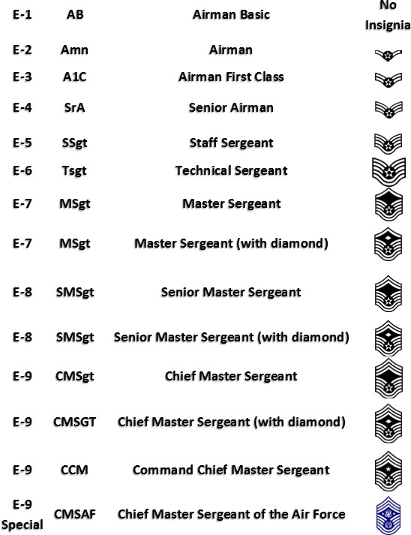**Enlisted**

**Officer**

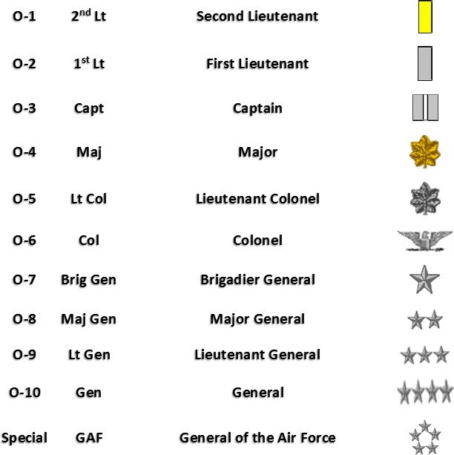

**Space Force**

**Enlisted**

|  |  |  |  |
| --- | --- | --- | --- |
| E1 | Specialist 1 | Spc1 | Preferred term is Specialist but Spec1 or Specialist 1 are  both acceptable |
| E2 | Specialist 2 | Spc2 | Preferred term is Specialist but Spec2 or Specialist 2 are  both acceptable |
| E3 | Specialist 3 | Spc3 | Preferred term is Specialist but Spec3 or Specialist 3 are  both acceptable |
| E4 | Specialist 4 | Spc4 | Preferred term is Specialist but Spec4 or Specialist 4 are  both acceptable |
| E5 | Sergeant | Sgt | Sergeant |
| E6 | Technical Sergeant | TSgt | Sergeant or Technical Sergeant or Tech Sergeant |
| E7 | Master Sergeant | MSgt | Sergeant or Master Sergeant |
| E8 | Senior Master Sergeant | SMSgt | Senior or Senior Master Sergeant |
| E9 | Chief Master Sergeant | CMSgt | Chief or Chief Master Sergeant |
| E9 | Chief Master Sergeant of the  Space Force | CMSSF | Chief or Chief Master Sergeant of the Space Force |

**Officer**

|  |  |  |  |
| --- | --- | --- | --- |
| O1 | Second Lieutenant | 2d Lt | Second Lieutenant or Lieutenant |
| O2 | First Lieutenant | 1st Lt | First Lieutenant or Lieutenant |
| O3 | Captain | Capt | Captain |
| O4 | Major | Maj | Major |
| O5 | Lieutenant Colonel | Lt Col | Lieutenant Colonel or Colonel |
| O6 | Colonel | Col | Colonel |
| O7 | Brigadier General | Brig Gen | Brigadier General or General |
| O8 | Major General | Maj Gen | Major General or General |
| O9 | Lieutenant General | Lt Gen | Lieutenant General or General |
| O10 | General | Gen | General |

**Army**

**Enlisted**

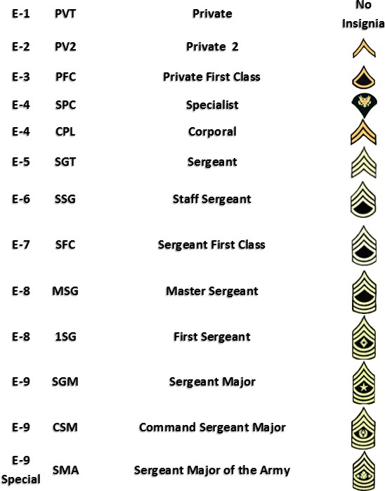

**Officer**

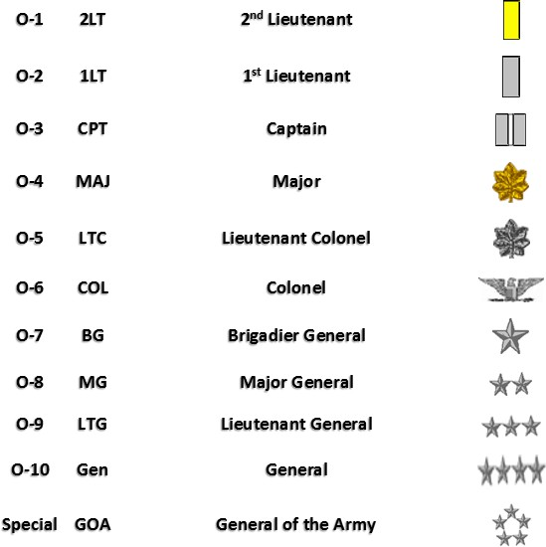

**Navy**

**Enlisted**

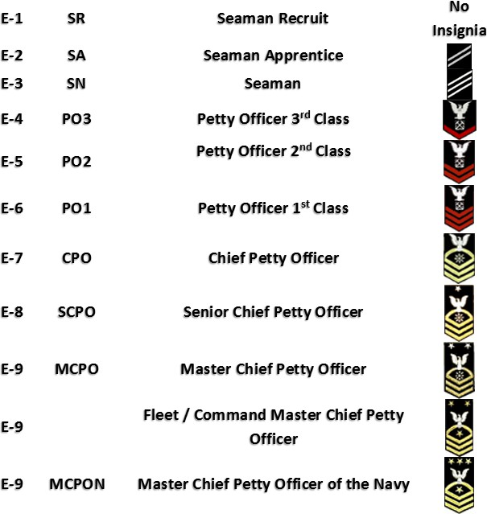

**Officer**



|  |  |  |
| --- | --- | --- |
| 0-1 | ENS | Ensign |
| 0-2 | LTJG | Ueut,enant Junior Grade |
| 0-3 | LT | Ueut,enant |
| 0-4, | L:GDR | Ueut,enant ·Commander |
| 0-5 | ·CDR | ·Commander |
| 0-6 | ·CAP·T | ·Captain |
| 0-7 | RDML | Read Admiral (low,er half) |
| 0-8 | RADM | R,ead Admiral (upper half) |

VAD

0-9 Vice Admiral

M

0-101 ADM Admiral

0-11 FADM Fleet Admiral

Warrant Offi:cers Ranks

i

|  |  |  |  |  |
| --- | --- | --- | --- | --- |
| w-1 | wot |  | Warrant OffiGer 1 * NO L:ONGER IN USE | |
|  |  |  |  | Ohi,ef Warrant Offic,er 2 |
| W-3 | CW03 |  |  | Ohi,ef Warrant Offic,er 3 |
| W-4 | CW04 |  |  | Ohi,ef Warrant Offic,er 4 |
| W-5 | CWOS |  |  | Ohi,ef Warrant Offic,er 5 (Established 2002) |

I

I

rn

# Marines

**Enlisted**

* 1. PVT Private

'o, Insignia

* 1. PFC Privat,e First Class, *I\.*

•

* 1. LCpl Lance Corpora I

•

* 1. C1pl Corpo,r,al

E•5 Sgt Serg,eant

Staff Serg:eant

* 1. GySgt Gunnery Sergeant

First Sergeant

* 1. MSgt Master Sergieant
  2. MGySgt

E-9 SgtMaj

E-9 SgtMaj S pe-oial MarCor

1

Master Gunnery Sereeant

Sergeant Major

Sergeant Major of th1e Marine Corps

**Officer**

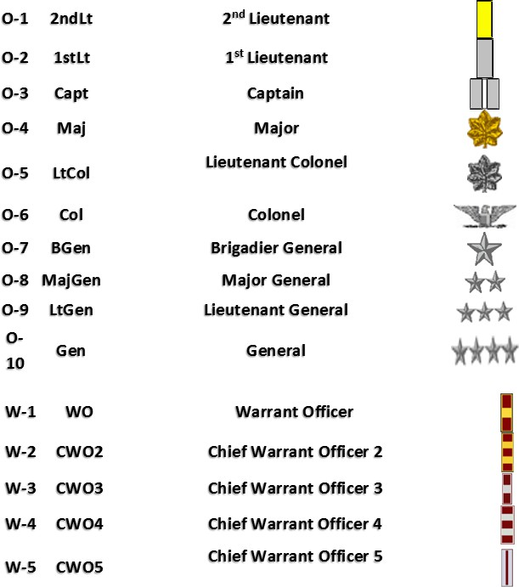

**Coast Guard**

**Enlisted**

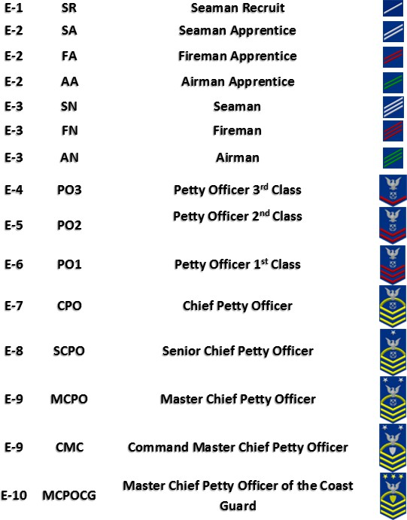

**Officer**

